Problem Statement
The Indian real estate market shows high variation in housing prices across states, cities, and property types. Buyers and investors often struggle to identify affordable regions, property trends, and market drivers such as furnishing status, property size, and amenities.
The objective of this Tableau dashboard is to:
- Analyze average housing prices across Indian states and cities.
- Identify affordability trends and regional variations.
- Compare property types, furnishing levels, and other housing attributes.
- Understand how size and year built influence property prices.

State-Level Price Heat Map
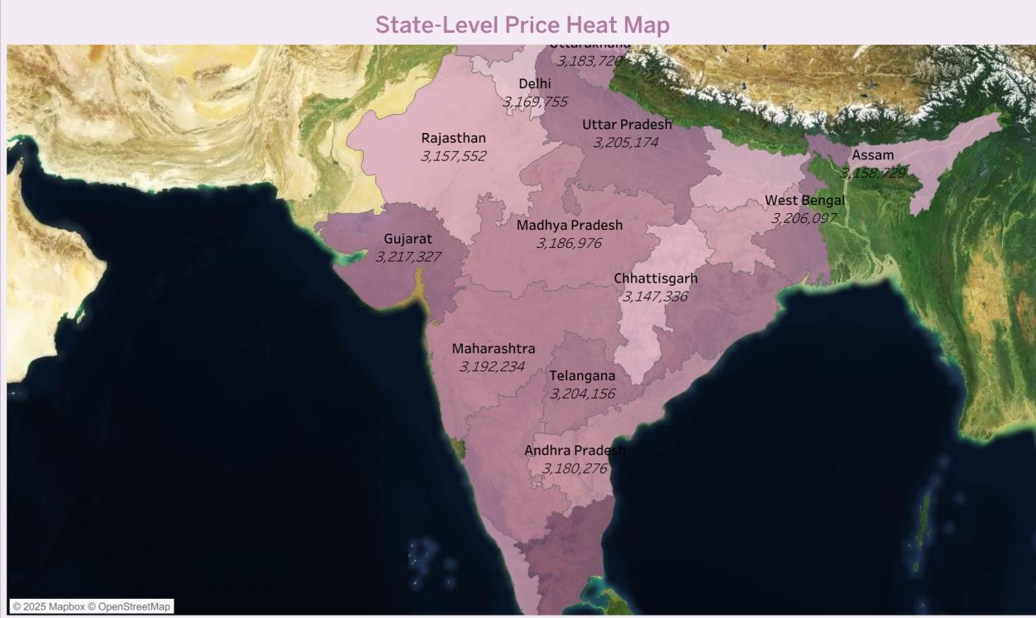

What the Graph Shows
This map visualizes average property prices across Indian states using color intensity.

Key Insights
- Darker shades represent higher housing prices — seen in Maharashtra, Delhi, and Karnataka, India’s major metro hubs.
- Lighter shades (Odisha, Chhattisgarh, Madhya Pradesh) represent more affordable housing markets.

Implication
The heat map visually identifies high-cost and low-cost states, guiding both investors (to high-return areas) and homebuyers (to affordable regions).

Trend Over Time (Line Chart)
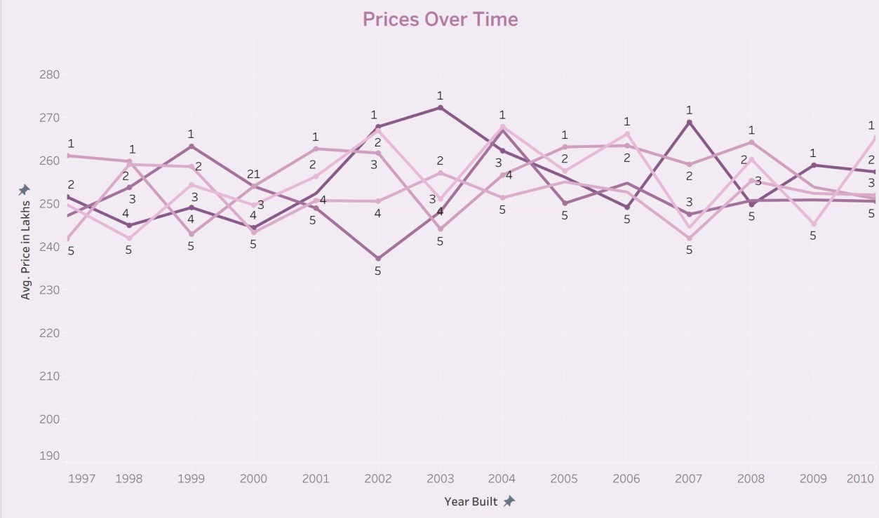

What the Graph Shows
Displays the average price by year built, showing how property prices evolve over time.

Key Insights
- A rising trend suggests appreciation in property value over the years.
- Recent constructions (post-2015) typically have higher prices, indicating demand for modern housing with better infrastructure.

Implication
Buyers may prefer older properties for affordability, while investors can use newer properties as indicators of growth potential.

Distribution of Property Types
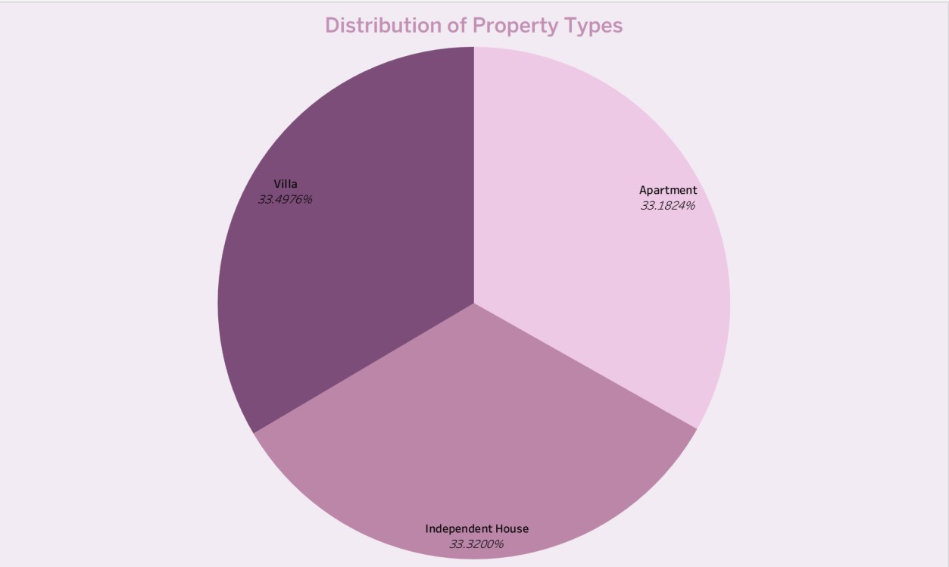

What the Graph Shows
A pie or bar chart showing the proportion of Apartments, Villas, and Independent Houses.

Key Insights
- Apartments dominate, reflecting urban housing preferences.
- Independent Houses and Villas form smaller segments, often in suburban or less dense regions.

Implication
Developers and policymakers can use this to assess housing demand type — more apartment projects in cities and more independent houses in smaller towns.

Average Property Prices Across States
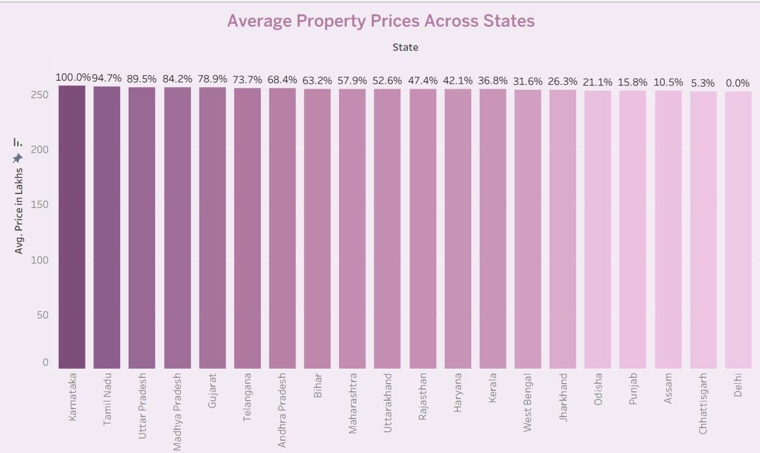

What the Graph Shows
A bar chart comparing the average price (in lakhs) across different states.

Key Insights
- Maharashtra and Delhi are on the higher end.
- Odisha and Chhattisgarh fall on the lower end.

Implication
This allows an easy visual comparison of housing affordability across states, confirming the economic disparity between metro and non-metro regions.

Most Affordable States
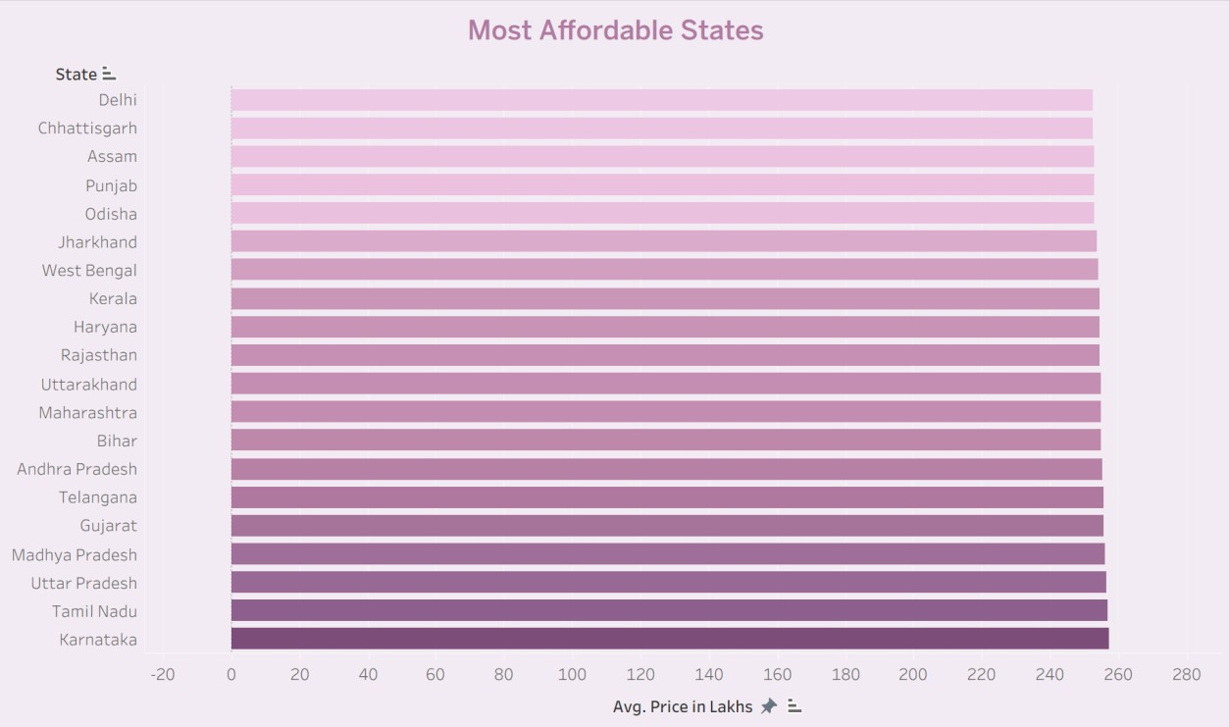

What the Graph Shows
A sorted bar chart ranking states from most to least affordable based on their average property price.

Key Insights
- Odisha and Chhattisgarh are among the most affordable.
- Maharashtra and Delhi remain at the costliest end.

Implication
Ideal for identifying potential housing markets for first-time buyers and affordable housing developers.

Furnishing Status Comparison
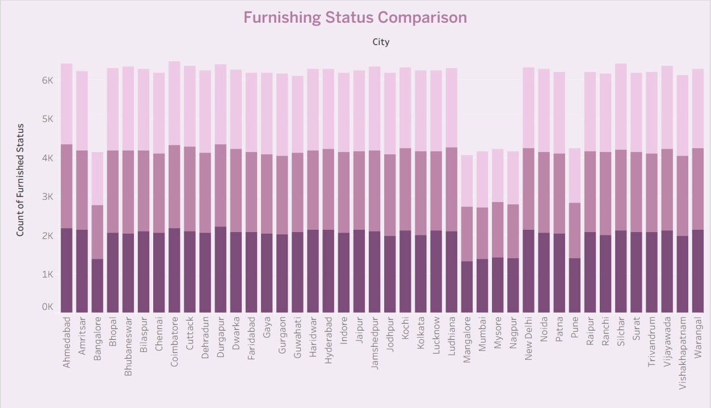

What the Graph Shows
A stacked bar chart comparing the count of Furnished, Semi-Furnished, and Unfurnished properties across different cities.

Key Insights
- Metro cities like Bangalore, Hyderabad, and Mumbai have higher proportions of furnished or semi-furnished properties.
- Smaller cities lean toward unfurnished homes.

Implication
Furnishing trends reveal rental demand and lifestyle expectations. Furnished apartments dominate in areas with higher migration and working professionals.

Affordability Index (Bubble Chart)
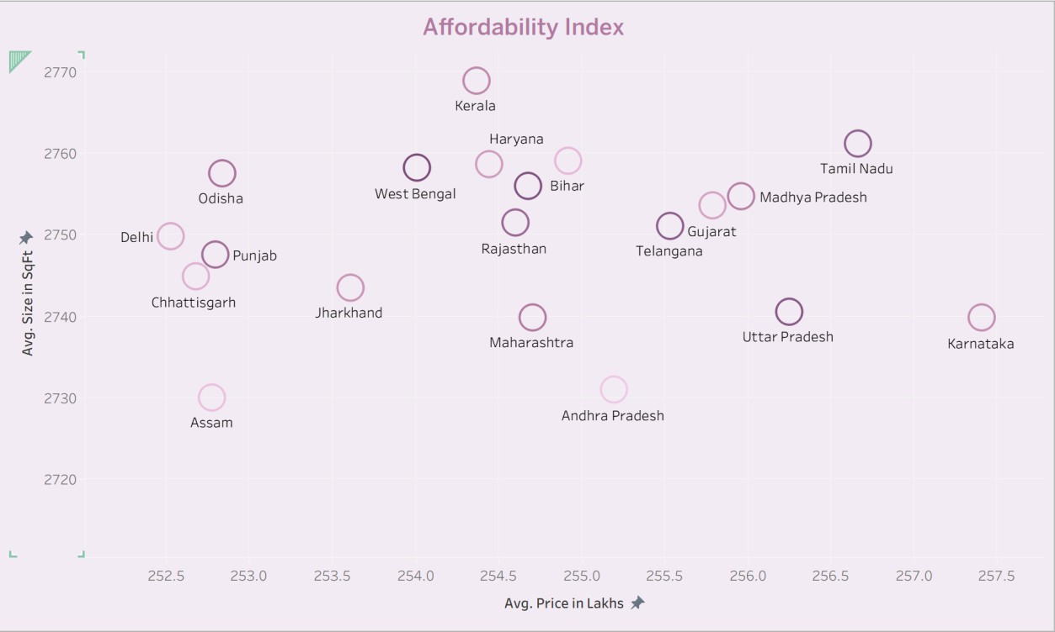

What the Graph Shows
Plots Average Price (X-axis) vs Average Size (Y-axis) for each state. The bubble size represents the number of properties or another factor.

Key Insights
- States offering larger sizes at lower prices (e.g., Odisha, Madhya Pradesh) are the most affordable.
- States with smaller sizes but higher prices (Delhi, Maharashtra) represent premium urban markets.

Implication
The chart visually identifies where buyers get more space for their money — a practical affordability indicator.

KPI Summary Cards (Maximum, Minimum, Average Price, Total Properties, Average Size) What the Metrics Show
These key performance indicators (KPIs) provide a quick snapshot of the housing market:
- Maximum Price – highest priced property in the dataset (e.g., ₹500 lakhs = ₹5 crores).
- Minimum Price – lowest priced property (e.g., ₹10 lakhs).
- Average Price – mean property price across all listings.
- Total Properties – total number of properties analyzed.
- Average Size – mean area of all properties in square feet.

Key Insights
- The large gap between maximum and minimum prices highlights strong market diversity — from affordable to luxury housing.
- The average price helps indicate the mid-market housing range.
- Total properties confirm the dataset’s comprehensiveness and sample size.

Implication
These KPIs provide investors and policymakers a top-level understanding of the housing landscape before diving into regional or categorical details.

Overall Insights from the Dashboard
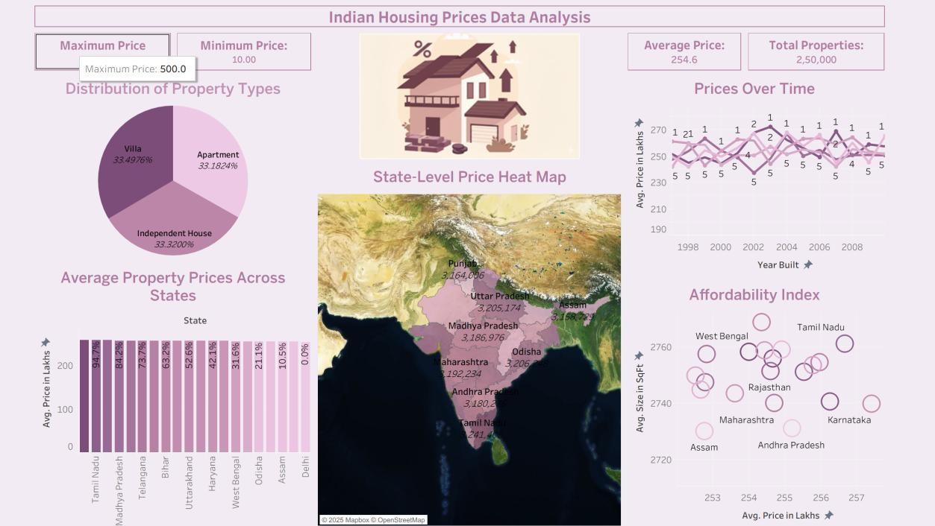
- Regional Price Variation: Metro states command premium property prices, while central and eastern states are more affordable.
- Property Type Trends: Apartments dominate the urban real estate landscape.
- Affordability Factors: Larger sizes and lower price-per-sqft ratios improve affordability.
- Modern Housing Demand: Newer constructions (post-2015) show higher prices, reflecting market modernization.
- Furnishing Patterns: Furnished homes are common in major employment hubs due to high rental demand.

Data-Driven Recommendations
Challenge | Insight Recommended Action
High housing prices in metros | Demand outpaces Promote affordable housing projects  supply and suburban expansion
Low affordability in smaller states | Larger homes but low Encourage infrastructure growth to  demand attract investors
Furnished property demand in cities | Rental market Builders should focus on ready-todominance move properties

Conclusion
The Tableau dashboard offers a complete visualization of the Indian housing market. It highlights how location, property type, size, and amenities influence housing affordability and price distribution.
Key takeaways:
- Metro areas are costlier but offer better amenities.
- Smaller states provide larger, affordable properties.
- Furnishing trends reflect evolving urban lifestyles.
- Price appreciation over time indicates overall market growth.
In summary:
The dashboard serves as a valuable analytical tool for buyers, investors, and policymakers to make informed real estate decisions in India’s diverse housing market.

